**IPL ANALYSIS**

Objective Questions

1. List the different dtypes of columns in table “ball_by_ball” (using information schema)

**SQL query**

SELECT COLUMN_NAME, DATA_TYPE

FROM INFORMATION_SCHEMA.COLUMNS

WHERE TABLE_NAME = 'ball_by_ball'

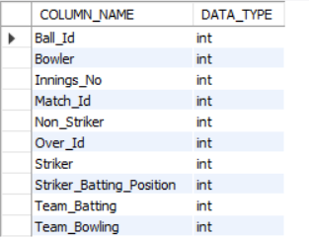

1. What is the total number of run scored in 1st season by RCB (bonus : also include the extra runs using the extra runs table)  
     
   **Approach:** For resolving this question first we need to join ball_by_ball, batsman_scored, extra_runs,team and matches table to get proper output. Then taking sum of runs_scored and extra runs to get total scores by RCB in season 1.

**SQL query:**

select sum(bs.Runs_Scored+e.Extra_Runs) as Total_runs_by_RCB from ball_by_ball b left join batsman_scored bs on b.Match_Id=bs.Match_Id and b.Over_Id=bs.Over_Id and b.Ball_Id=bs.Ball_Id and b.Innings_No=bs.Innings_No

left join extra_runs e on b.Match_Id=e.Match_Id and b.Over_Id=e.Over_Id and b.Ball_Id=e.Ball_Id and b.Innings_No=e.Innings_No

join team t on b.Team_Batting=t.Team_Id

join matches m on b.Match_Id = m.Match_Id

where m.Season_Id=1;

**Output:**

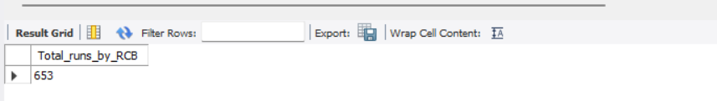

**Visualization:**

**Conclusion:** From above query, output and charts we can conclude that in season 1 RCB scored only 653 runs.

1. How many players were more than age of 25 during season 2 ?

**Approach:** For calculating count of players were more than age of 25 during season 2, first need to join required tables then absolute difference between date of birth and season 2 year to get desired output.

**SQL query**

SELECT COUNT(*) AS players_over_25

FROM Player p

JOIN Season s ON s.Season_Id = 2

WHERE DATE_FORMAT(CURDATE(), '%Y') - YEAR(p.DOB) > 25

AND s.Season_Year = 2009;

**Output:**



1. How many matches did RCB win in season 1?  
     
   **Approach:** first need to join matches, team and matches_won table then filter for season 1 and team RCB to get desired output.

**SQL query**

SELECT COUNT(*) AS matches_won

FROM matches m

JOIN team t ON (m.Match_Winner = t.Team_Id)

WHERE m.Season_Id = 1 AND t.Team_Name = 'Royal Challengers Bangalore';

**Output:**



1. List top 10 players according to their strike rate in last 4 seasons  
     
   **Approach:** first need to join ball_by_ball, batsman_scored, player_match, matches and player then calculate strike rate arrange in desc , filter it using season id from last 4 seasons select top 10 players using limit.

**SQL query:**

SELECT

p.Player_id,

p.Player_Name,

(SUM(bs.Runs_Scored) * 100.0 / COUNT(b.Ball_Id)) AS Strike_rate

FROM

ball_by_ball b

JOIN

batsman_scored bs ON b.Match_Id = bs.Match_Id

AND b.Over_Id = bs.Over_Id

AND b.Ball_Id = bs.Ball_Id

JOIN

player_match pm ON pm.Match_Id = b.Match_Id

AND pm.Player_Id = b.Striker

join matches m on m.Match_Id=b.Match_Id

JOIN

player p ON p.Player_Id = pm.Player_Id

where m.Season_Id in ('6','7','8','9')

GROUP BY p.Player_id, p.Player_Name

order by Strike_rate desc limit 10;

**Output:**

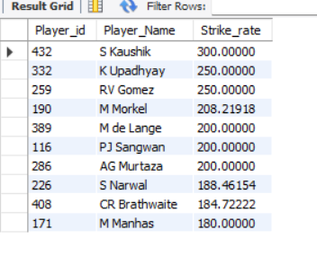

**Visualization:**

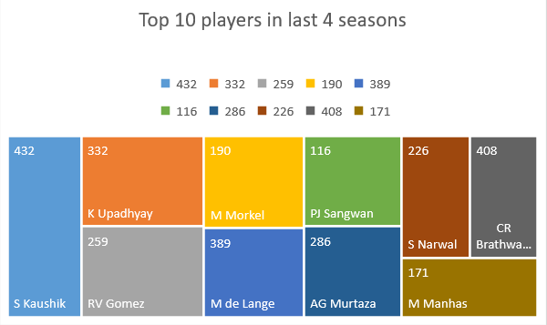

**Conclusion:** From above Output and chart we can conclude that S Kaushik, K Upadhyay and RV Gomez are the top most players in last 4 seasons.

1. What is the average runs scored by each batsman considering all the seasons?

**Approach:** For calculating average runs scored by each batsman considering all seasons first need to join batsman_scored, ball_by_ball, matches and player table then create cte for players total runs across all season and then take average of total runs in other cte for all players across all seasons to get proper output.

**SQL query:**

WITH per_player_per_season AS (

SELECT p.Player_Name AS batsman,   
 m.Season_Id, SUM(bs.Runs_Scored) AS total_runs  
 FROM batsman_scored bs   
 JOIN ball_by_ball b ON bs.Match_Id = b.Match_Id   
 AND bs.Over_Id = b.Over_Id   
 AND bs.Ball_Id = b.Ball_Id   
 AND bs.Innings_No = b.Innings_No  
 JOIN matches m ON m.Match_Id = bs.Match_Id  
 JOIN player p ON p.Player_Id = b.Striker  
 GROUP BY   
 p.Player_Name, m.Season_Id  
),

avg_runs1 AS (

SELECT batsman, AVG(total_runs) AS avg_runs  
 FROM   
 per_player_per_season  
 WHERE Season_Id <= 9  
 GROUP BY   
 batsman

)

SELECT batsman, avg_runs  
FROM avg_runs1  
ORDER BY  
 avg_runs DESC;

**Output:**

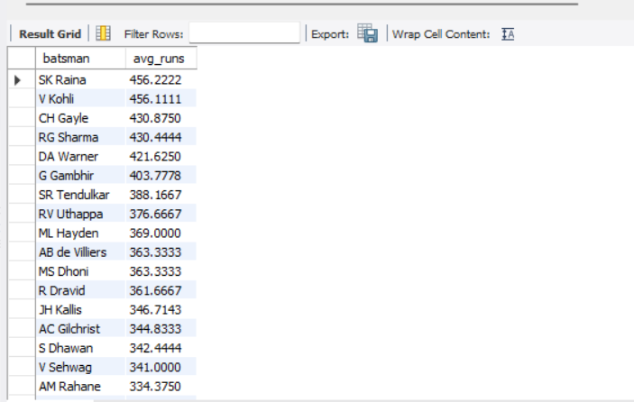

**Conclusion**: From above query and output we can calculate average runs for each batsman considering all season. SK Raina, V Kohli and CH Gayle are top 3 players for all seasons.

1. What are the average wickets taken by each bowler considering all the seasons?  
   **Approach:** for resolving question joins required table from schema and first calculate total wickets and then take an average of total wickets with respective player names and seasons.

**SQL query**

Select

p.Player_Name,

avg(wt.Player_Out) as AvgWickets

from Player p

join

Player_Match pm on p.Player_Id=pm.Player_Id

join

Matches m on pm.Match_Id= m.Match_Id

join

Season s on m.Season_Id=s.Season_Id

join

Wicket_Taken wt on wt.Match_Id=m.Match_ID

group by

p.Player_Name

**Output**

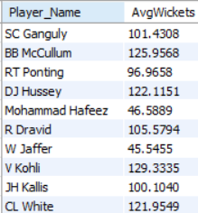  
**Conclusion:** from above query and output we can conclude that average wickets considering all seasons. From output we can conclude that Sc Ganguly,BBMcCullum,RT Ponting are top 3 bowlers till season 9.

1. List all the players who have average runs scored greater than overall average and who have taken wickets greater than overall average  
     
   **Approach:** first find total runs and matches played for batsman then calculate total wicket taken and matches played for bowlers then calculate overall avg runs and overall avg wickets by using cross join for above two cte’s. After that player table join with bowler_stat and batsman_stat.

**SQL query**

with AvgRuns as (

Select

p.Player_Name,

avg(bs.Runs_Scored) as AvgRuns

from Player p

join Player_Match pm on p.Player_Id = pm.Player_Id

join Matches m on pm.Match_Id = m.Match_Id

join Season s on m.Season_Id = s.Season_Id

join Batsman_Scored bs on bs.Match_Id = m.Match_ID

group by p.Player_Name

),

AvgWickets as (

Select

p.Player_Name,

avg(wt.Player_Out) as AvgWickets

from Player p

join Player_Match pm on p.Player_Id = pm.Player_Id

join Matches m on pm.Match_Id = m.Match_Id

join Season s on m.Season_Id = s.Season_Id

join Wicket_Taken wt on wt.Match_Id = m.Match_ID

group by p.Player_Name

),

OverallAverages as (

Select

(Select avg(bs.Runs_Scored) from Batsman_Scored bs) as OverallAvgRuns,

(Select avg(wt.Player_Out) from Wicket_Taken wt) as OverallAvgWickets

)

Select

r.Player_Name

from AvgRuns r

join AvgWickets w on r.Player_Name = w.Player_Name

cross join OverallAverages oa

where r.AvgRuns > oa.OverallAvgRuns

and w.AvgWickets > oa.OverallAvgWickets;  
**Output**

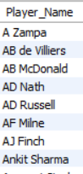  
  
**Conclusion:** From above query we can conclude thatthe query is designed to identify players who are exceptional in both batting and bowling, and provides a way to compare their performance to the overall averages of all batsmen and bowlers.

1. Create a table rcb_record table that shows wins and losses of RCB in an individual venue.  
   **Approach:** The query creates a table rcb_record that stores the **win** and **loss** counts for RCB across different **venues** and **seasons**. CASE statement to count the wins and losses based on whether RCB was one of the teams (Team_1 or Team_2) and if they won the match.

**SQL query:**

CREATE TABLE rcb_record AS

SELECT

v.Venue_Name,

s.Season_Id,

SUM(CASE

WHEN (m.Team_1 = 2 OR m.Team_2 = 2) AND m.Match_Winner = 2 THEN 1

ELSE 0

END) AS WIN,

SUM(CASE

WHEN (m.Team_1 = 2 OR m.Team_2 = 2) AND m.Match_Winner != 2 THEN 1

ELSE 0

END) AS LOSS

FROM Matches m

JOIN Venue v ON m.Venue_Id = v.Venue_Id

JOIN Season s ON m.Season_Id = s.Season_Id

WHERE m.Team_1 = 2 OR m.Team_2 = 2

GROUP BY v.Venue_Name, s.Season_Id;

select * from rcb_record  
**Output**

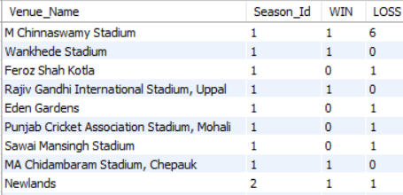  
  
**Conclusion:** This query efficiently tracks RCB's performance by tallying wins and losses for each venue and season. The data will help analyse RCB's success patterns based on venue and season over time.

1. What is the impact of bowling style on wickets taken.

**Approach**: The query is creating output for the impact of bowling style on wickets taken using joins and perform some mathematical tasks to calculate wicket_taken, matches_played, balling skill impact on wickets.

**SQL Query:**

with bowler_wickets as(select p.Player_Id,bs.Bowling_Skill, count(w.Player_Out)as wickets_taken,

count(b.Match_Id) as matches_played

from ball_by_ball b

join bowling_style bs on b.Team_Bowling=bs.Bowling_Id

join wicket_taken w on b.Match_Id=w.Match_Id

and b.Over_Id=w.Over_Id and b.Ball_Id=w.Ball_Id and b.Innings_No=w.Innings_No

join player_match p on b.Match_Id=p.Match_Id group by 1,2)

select bw.Bowling_Skill,sum(bw.wickets_taken) as total_wickets, count(Player_Id) as no_of_bowlers, avg(wickets_taken) as avg_wickets_per_bowlers,avg(wickets_taken/matches_played) as avg_wickets_per_match

from bowler_wickets bw group by bw.Bowling_Skill, bw.wickets_taken order by avg_wickets_per_match;

**Output:**

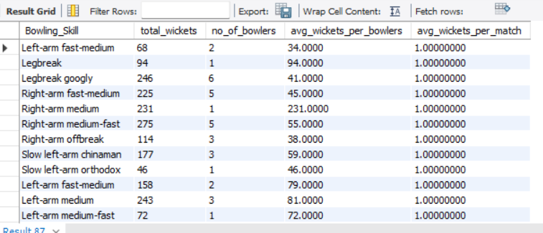

**Conclusion:** The query calculates bowling performance metrics grouped by **bowling skill type**. It computes the **total wickets taken**, the **number of bowlers** per skill type, the **average wickets per bowler,** and the **average wickets per match** for each bowling skill. This helps analyse how different bowling styles perform in terms of wicket-taking efficiency across matches and bowlers.

1. Write the sql query to provide a status of whether the performance of the team better than the previous year performance on the basis of number of runs scored by the team in the season and number of wickets taken   
   **Approach:** First calculate team performance and then calculate previous year performance using lag function. By doing comparisons using case statement to decide performance is mixed, better or worsed.

**SQL query**

WITH team_performance AS (

SELECT

m.Season_Id,

m.Team_1,

SUM(bs.Runs_Scored) AS total_runs,

COUNT(w.Player_Out) AS total_wickets

FROM

Matches m

JOIN

ball_by_ball b ON m.Match_Id = b.Match_Id

LEFT JOIN

Batsman_Scored bs ON b.Match_Id = bs.Match_Id AND b.Over_Id = bs.Over_Id AND b.Ball_Id = bs.Ball_Id

LEFT JOIN

Wicket_Taken w ON b.Match_Id = w.Match_Id AND b.Over_Id = w.Over_Id AND b.Ball_Id = w.Ball_Id

GROUP BY

m.Season_Id, m.Team_1

),

performance_comparison AS (

SELECT

tp.Season_Id,

tp.Team_1,

tp.total_runs,

tp.total_wickets,

LAG(tp.total_runs, 1) OVER (PARTITION BY tp.Team_1 ORDER BY tp.Season_Id) AS prev_season_runs,

LAG(tp.total_wickets, 1) OVER (PARTITION BY tp.Team_1 ORDER BY tp.Season_Id) AS prev_season_wickets

FROM

team_performance tp

)

SELECT

Season_Id,

Team_1,

total_runs,

total_wickets,

prev_season_runs,

prev_season_wickets,

CASE

WHEN total_runs > prev_season_runs AND total_wickets > prev_season_wickets THEN 'Better'

WHEN total_runs = prev_season_runs AND total_wickets = prev_season_wickets THEN 'Same'

ELSE 'Worse'

END AS performance_status

FROM

performance_comparison

WHERE

prev_season_runs IS NOT NULL -- To exclude the first season

ORDER BY

Team_1, Season_Id;  
**Output:**

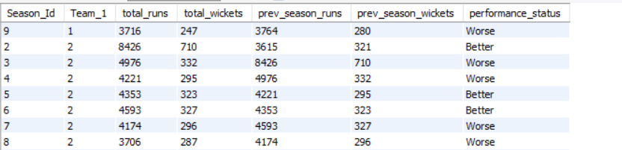

**Conclusion:** The query provides comparison of current performance is better than previous year or not. By using this, then can analyse improvement points and they will work on it to improve their performance if their performance was worse. This analysis will increase overall performance of team.

1. Can you derive more KPIs for the team strategy if possible?  
   **Approach**: for deriving more KPI’s for team strategy first we can calculate team id, team name, matches_played, total innings, total runs, total_wickets, fours, sixes, dot balls , balls faced, matches won ,strike rate, avg runs per match, avg wickets per match, use case statement to decide performance of the as compared to previous year.

**SQL query:**

WITH team_performance AS (

SELECT

m.Season_Id,

t.Team_Id,

t.Team_Name,

COUNT(DISTINCT m.Match_Id) AS matches_played,

COUNT(b.Innings_No) AS total_innings,

SUM(bs.Runs_Scored) AS total_runs,

COUNT(w.Player_Out) AS total_wickets,

SUM(CASE WHEN bs.Runs_Scored = 4 THEN 1 ELSE 0 END) AS fours,

SUM(CASE WHEN bs.Runs_Scored = 6 THEN 1 ELSE 0 END) AS sixes,

SUM(CASE WHEN bs.Runs_Scored = 0 THEN 1 ELSE 0 END) AS dot_balls,

COUNT(b.Ball_Id) AS balls_faced,

COUNT(DISTINCT CASE WHEN m.Win_Type = t.Team_Id THEN m.Match_Id END) AS matches_won

FROM team t

JOIN matches m ON t.Team_Id IN (m.Team_1, m.Team_2)

LEFT JOIN ball_by_ball b ON b.Match_Id = m.Match_Id

LEFT JOIN batsman_scored bs ON b.Match_Id = bs.Match_Id AND b.Over_Id = bs.Over_Id AND b.Ball_Id = bs.Ball_Id AND b.Innings_No = bs.Innings_No

LEFT JOIN wicket_taken w ON w.Match_Id = b.Match_Id AND w.Over_Id = b.Over_Id AND w.Ball_Id = b.Ball_Id AND w.Innings_No b.Innings_No

GROUP BY 1, 2, 3

),

performance_comparison AS (

SELECT

Season_Id,

Team_Id,

Team_Name,

matches_played,

total_innings,

total_runs,

total_wickets,

fours,

sixes,

dot_balls,

balls_faced,

matches_won,

ROUND(total_runs/balls_faced * 100, 2) AS strike_rate,

ROUND(total_runs/matches_played, 2) AS avg_runs_per_match,

ROUND(total_wickets/matches_played, 2) AS avg_wickets_per_match,

ROUND(dot_balls/matches_played * 100, 2) AS dot_balls_percentage,

LAG(total_runs) OVER (PARTITION BY Team_Id ORDER BY Season_Id) AS prev_year_runs,

LAG(total_wickets) OVER (PARTITION BY Team_Id ORDER BY Season_Id) AS prev_year_wickets,

LAG(ROUND(total_runs/balls_faced, 2)) OVER (PARTITION BYTeam_Id ORDER BY Season_Id) AS prev_year_strike_rate

FROM team_performance

)

SELECT

Season_Id,

Team_Name,

matches_played,

total_runs,

total_wickets,

fours,

sixes,

strike_rate,

avg_runs_per_match,

avg_wickets_per_match,

prev_year_runs,

prev_year_wickets,

prev_year_strike_rate,

CASE

WHEN total_runs > prev_year_runs AND total_wickets > prev_year_wickets AND strike_rate > prev_year_strike_rate THEN 'Significantly Better'

WHEN total_runs > prev_year_runs AND total_wickets > prev_year_wickets THEN 'Better'

WHEN total_runs < prev_year_runs AND total_wickets < prev_year_wickets AND strike_rate < prev_year_strike_rate THEN 'Significantly Worse'

WHEN total_runs < prev_year_runs AND total_wickets < prev_year_wickets THEN 'Worse'

WHEN strike_rate > prev_year_strike_rate THEN 'Improved Scoring Rate'

ELSE 'Mixed'

END AS performance_status

FROM performance_comparison

WHERE prev_year_runs IS NOT NULL AND prev_year_wickets IS NOT NULL

ORDER BY Team_Name, Season_Id;

**Output:**

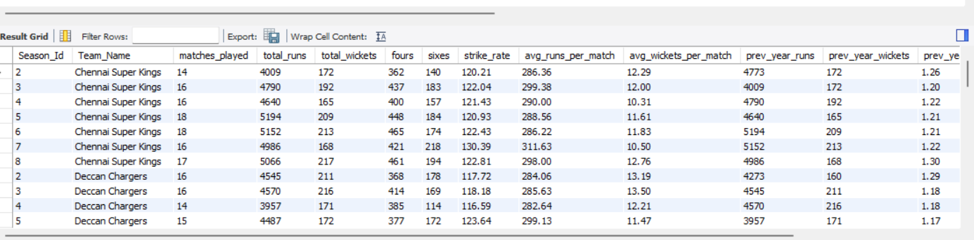

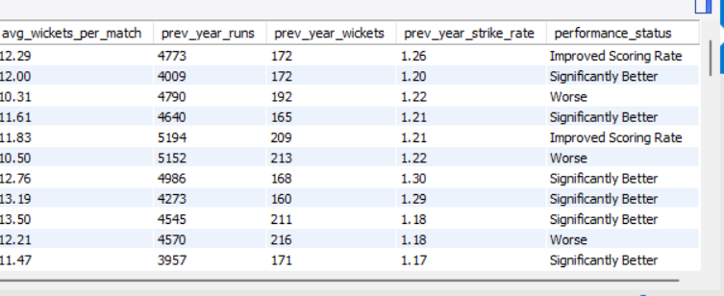

**Conclusion:** From above output we can conclude that this analysis will help us to build strategy for increasing team performance in matches.

1. Using SQL, write a query to find out average wickets taken by each bowler in each venue. Also rank the gender according to the average value.  
   **Approach:** For resolving this query first need to calculate bowler’s performance on different venues like total wickets, avg_wickets and we need to give rank to the bowlers using dense rank function to get proper output.

**SQL query:**

WITH bowler_performance AS (

SELECT

b.Bowler,

v.Venue_Name,

COUNT(w.Player_Out) AS total_wickets

FROM

matches m

JOIN

ball_by_ball b ON m.Match_Id = b.Match_Id

JOIN

wicket_taken w ON b.Match_Id = w.Match_Id

AND w.Over_Id = b.Over_Id

AND w.Ball_Id = b.Ball_Id

AND w.Innings_No = b.Innings_No

JOIN

venue v ON v.Venue_Id = m.Venue_Id

GROUP BY

1, 2

),

avg_wickets AS (

SELECT

Bowler,

Venue_Name,

total_wickets,

AVG(total_wickets) OVER(PARTITION BY Bowler) AS avg_wickets

FROM

bowler_performance

),

ranked_bowler AS (

SELECT

Bowler,

Venue_Name,

total_wickets,

avg_wickets,

DENSE_RANK() OVER(ORDER BY avg_wickets DESC) AS bowler_rank

FROM

avg_wickets

)

SELECT * FROM ranked_bowler ORDER BY avg_wickets DESC, total_wickets DESC;

**Output:**

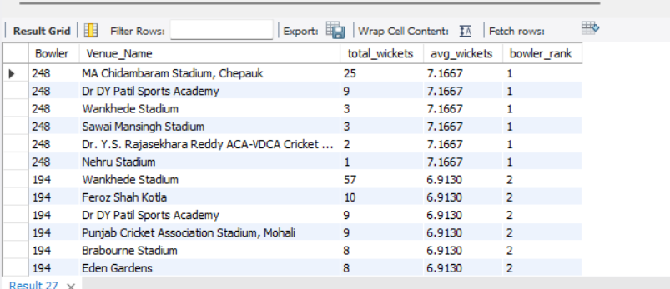

**Conclusion:** From the above query and output we can conclude that it ranked bowlersbased on their **average wickets taken per venue.** This helps identify top-performing bowlers by comparing their wicket-taking consistency across different venues.

1. Which of the given players have consistently performed well in past seasons? (will you use any visualisation to solve the problem) **Approach:** For calculating consistency of given players we need to some calculations like total runs, matches played, sixes, fours, average runs across seasons, average wickets across season, season above 30 runs and season above 2 wickets. With the help of this parameter we can decide players who have consistently performed well in past.

**SQL query:**

WITH player_performance AS (

SELECT

m.Season_Id,

p.Player_Id,

p.Player_Name,

SUM(bs.Runs_Scored) AS total_runs,

COUNT(DISTINCT m.Match_Id) AS matches_played,

-- Count the number of wickets where the player was the bowler

SUM(CASE WHEN w.Player_Out IS NOT NULL OR p.Player_Id = b.Bowler THEN 1 ELSE 0 END) AS wickets_taken,

COUNT(b.Ball_Id) AS balls_faced,

SUM(CASE WHEN bs.Runs_Scored = 4 THEN 1 ELSE 0 END) AS fours,

SUM(CASE WHEN bs.Runs_Scored = 6 THEN 1 ELSE 0 END) AS sixes,

-- Calculate averages for each season

ROUND(SUM(bs.Runs_Scored) / COUNT(DISTINCT m.Match_Id), 2) AS avg_runs_per_match,

ROUND(SUM(CASE WHEN w.Player_Out IS NOT NULL OR p.Player_Id = b.Bowler THEN 1 ELSE 0 END)

/ COUNT(DISTINCT m.Match_Id), 2) AS avg_wickets_per_match

FROM

player p

JOIN

player_match pm ON p.Player_Id = pm.Player_Id

JOIN

matches m ON pm.Match_Id = m.Match_Id

JOIN

ball_by_ball b ON m.Match_Id = b.Match_Id AND p.Player_Id = b.Striker

JOIN

batsman_scored bs ON b.Match_Id = bs.Match_Id AND b.Over_Id = bs.Over_Id AND b.Ball_Id = bs.Ball_Id

LEFT JOIN

wicket_taken w ON b.Match_Id = w.Match_Id AND b.Over_Id w.Over_Id AND b.Ball_Id = w.Ball_Id

GROUP BY

m.Season_Id, p.Player_Id, p.Player_Name

)

SELECT

Player_Id,

Player_Name,

COUNT(DISTINCT Season_Id) AS seasons_played,

AVG(avg_runs_per_match) AS avg_runs_across_seasons,

AVG(avg_wickets_per_match) AS avg_wickets_across_seasons,

COUNT(CASE WHEN avg_runs_per_match > 50 THEN 1 END) AS seasons_above_30_runs,

COUNT(CASE WHEN avg_wickets_per_match > 2 THEN 1 END) AS seasons_above_2_wickets

FROM

player_performance

GROUP BY

Player_Id, Player_Name

HAVING

seasons_above_30_runs >= 2 OR seasons_above_2_wickets >= 2

ORDER BY

avg_runs_across_seasons DESC, avg_wickets_across_seasons DESC limit 15;

**Output:**

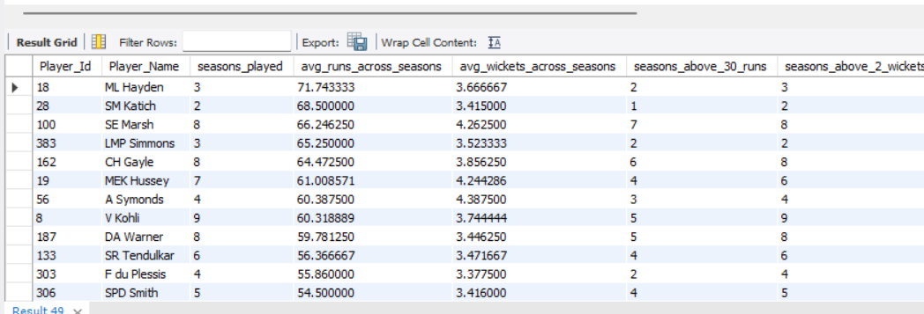

**Visualization:**

**Conclusion:** The query evaluates player performance across different seasons by calculating **total runs, wickets taken**, and other metrics like **fours, sixes**, and **balls faced**. It computes the **average runs** and **wickets per match** for each season, then filters and ranks players who have excelled by having at least two seasons with an average of more than 30 runs or 2 wickets per match. The final output ranks players based on their performance consistency over the seasons.

1. Are there players whose performance is more suited to specific venues or conditions? (how would you present this using charts?)   
   **Approach:** For resolving this we need to calculate average runs scored by each player, average wickets taken, seasons above 50 runs, seasons above 2 wickets etc.

**SQL query**

WITH player_performance AS (

SELECT

m.Season_Id,

v.Venue_Name, -- Include the venue name

p.Player_Id,

p.Player_Name,

SUM(bs.Runs_Scored) AS total_runs,

COUNT(DISTINCT m.Match_Id) AS matches_played,

-- Count the number of wickets where the player was the bowler

SUM(CASE WHEN w.Player_Out IS NOT NULL OR p.Player_Id = b.Bowler THEN 1 ELSE 0 END) AS wickets_taken,

COUNT(b.Ball_Id) AS balls_faced,

SUM(CASE WHEN bs.Runs_Scored = 4 THEN 1 ELSE 0 END) AS fours,

SUM(CASE WHEN bs.Runs_Scored = 6 THEN 1 ELSE 0 END) AS sixes,

-- Calculate averages for each season

ROUND(SUM(bs.Runs_Scored) / COUNT(DISTINCT m.Match_Id), 2) AS avg_runs_per_match,

ROUND(SUM(CASE WHEN w.Player_Out IS NOT NULL or p.Player_Id = b.Bowler THEN 1 ELSE 0 END)

/ COUNT(DISTINCT m.Match_Id), 2) AS avg_wickets_per_match

FROM

player p

JOIN

player_match pm ON p.Player_Id = pm.Player_Id

JOIN

matches m ON pm.Match_Id = m.Match_Id

JOIN

venue v ON m.Venue_Id = v.Venue_Id -- Join to get venue information

JOIN

ball_by_ball b ON m.Match_Id = b.Match_Id AND p.Player_Id = b.Striker

JOIN

batsman_scored bs ON b.Match_Id = bs.Match_Id AND b.Over_Id = bs.Over_Id AND b.Ball_Id = bs.Ball_Id

LEFT JOIN

wicket_taken w ON b.Match_Id = w.Match_Id AND b.Over_Id = w.Over_Id AND b.Ball_Id = w.Ball_Id

GROUP BY

m.Season_Id, v.Venue_Name, p.Player_Id, p.Player_Name

)

SELECT

Player_Id,

Player_Name,

Venue_Name, -- Include the venue name in the final output

COUNT(DISTINCT Season_Id) AS seasons_played,

AVG(avg_runs_per_match) AS avg_runs_across_seasons,

AVG(avg_wickets_per_match) AS avg_wickets_across_seasons,

COUNT(CASE WHEN avg_runs_per_match > 50 THEN 1 END) AS seasons_above_50_runs,

COUNT(CASE WHEN avg_wickets_per_match > 2 THEN 1 END) AS seasons_above_2_wickets

FROM

player_performance

GROUP BY

Player_Id, Player_Name, Venue_Name -- Group by Venue_Name as well

HAVING

seasons_above_50_runs >= 2 OR seasons_above_2_wickets >= 2

ORDER BY

avg_runs_across_seasons DESC, avg_wickets_across_seasons DESC;  
  
**Output:**

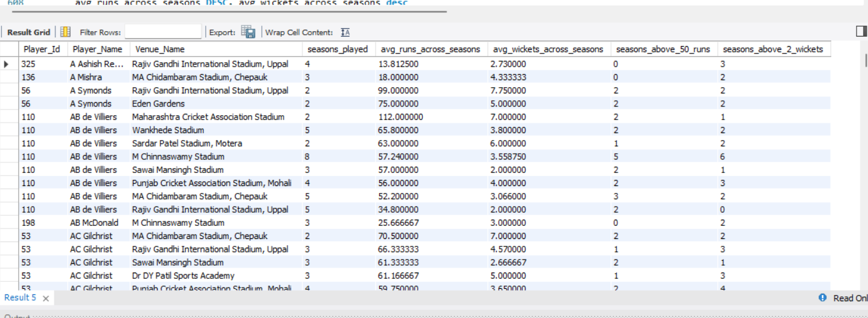  
  
**Visualization:**

Subjective Questions

1. How does toss decision have affected the result of the match ? (which visualisations could be used to better present your answer)

And is the impact limited to only specific venues?

**Approach:** For calculating toss decision have affected the result of match we need to use case statement for deciding toss decision either field or bat. Then calculate toss winner wins or losses, total matches, win_percentage to decide affect.

**SQL query:**

select v.Venue_Name,

case when m.Toss_Decide=1 then 'Field'else 'Bat' end as toss_decide,

sum(case when m.Toss_Winner=m.Match_Winner then 1 else 0 end ) as toss_winner_wins,

sum(case when m.Toss_Winner!=m.Match_Winner then 1 else 0 end ) as toss_winner_losses,

count(m.Match_Id) as total_matches,

round(sum(case when m.Toss_Winner=m.Match_Winner then 1 else 0 end)/count(m.Match_Id) *100 , 2) as win_percentage from matches m join venue v on m.Venue_Id=v.Venue_Id

group by v.Venue_Name,m.Toss_Decide order by v.Venue_Name,m.Toss_Decide;

**Output:**

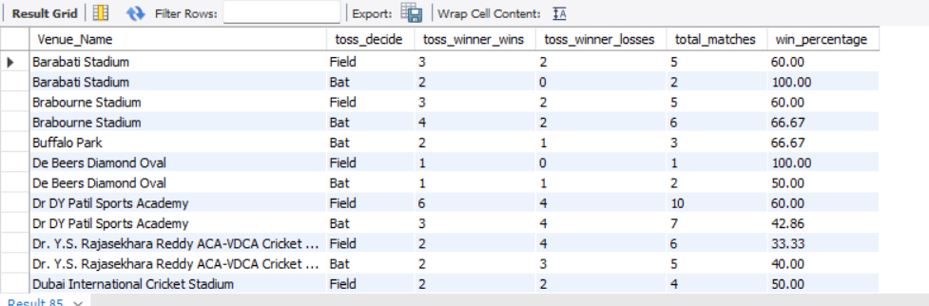

**Visualization:**

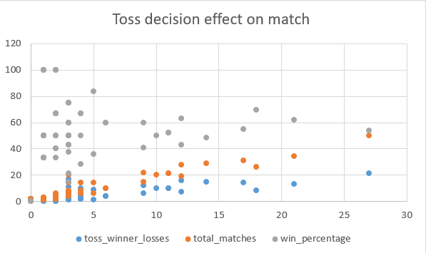

**Conclusion:** From the above chart we can conclude that total matches (orange dots) generally increase as we move right on the x-axis, suggesting more data for later teams or matches. Toss winner losses (blue dots) are consistently lower than total matches, which is expected. Win percentage (grey dots) shows high variability, ranging from very low (near 0%) to very high (near 100%). This suggests that winning the toss doesn't guarantee winning the match. Estimating from the spread of grey dots, it appears that the overall winning percentage when winning the toss is roughly in the 50-60% range. This suggests that winning the toss provides a slight advantage, but it's not a decisive factor in determining the match outcome.

1. Suggest some of the players who would be best fit for the team?  
   **Approach:** To analyse the performance of batsmen and bowlers, the query takes the following approach: joins tables, filter matches, group by player, calculation metric, sort and limit.

**SQL query:**

#Key parameters for selecting players

# A. Death over bowling performance

SELECT p.Player_Name,

SUM(CASE WHEN bb.Over_Id >= 16 AND bb.Over_Id <= 20 AND p.Player_Id IN (SELECT Bowler FROM ball_by_ball) THEN b.Runs_Scored ELSE 0 END) AS Death_Over_Runs_Conceded

FROM player p

JOIN ball_by_ball bb ON p.Player_Id = bb.Striker OR p.Player_Id = bb.Bowler

JOIN batsman_scored b ON bb.Match_Id = b.Match_Id AND bb.Over_Id = b.Over_Id AND bb.Ball_Id = b.Ball_Id AND bb.Innings_No = b.Innings_No

GROUP BY p.Player_Name

HAVING COUNT(bb.Ball_Id) > 100 AND Death_Over_Runs_Conceded != 0

ORDER BY Death_Over_Runs_Conceded ASC

LIMIT 10;

# B. Batting performance accross different venues

SELECT p.Player_Name,

v.Venue_Id,v.Venue_Name,

SUM(b.Runs_Scored) AS Total_Runs,

COUNT(b.Ball_Id) AS Balls_Faced,

ROUND(SUM(b.Runs_Scored) / COUNT(b.Ball_Id), 2)*100 AS Strike_Rate

FROM player p

JOIN ball_by_ball bb ON p.Player_Id = bb.Striker

JOIN matches m ON bb.Match_Id = m.Match_Id

JOIN venue v ON m.Venue_Id = v.Venue_Id

JOIN batsman_scored b

ON b.Match_Id = bb.Match_Id AND b.Over_Id = bb.Over_Id AND b.Ball_Id = bb.Ball_Id AND b.Innings_No = bb.Innings_No

GROUP BY p.Player_Name, v.Venue_Name

ORDER BY Total_Runs DESC, Strike_Rate DESC LIMIT 10;

**Output:**

For bowlers: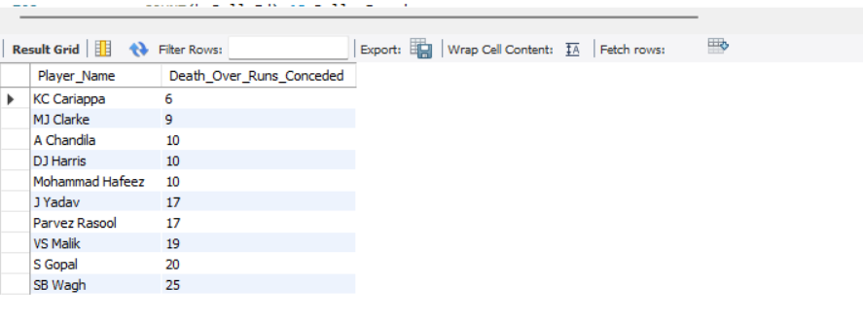

For batsman:

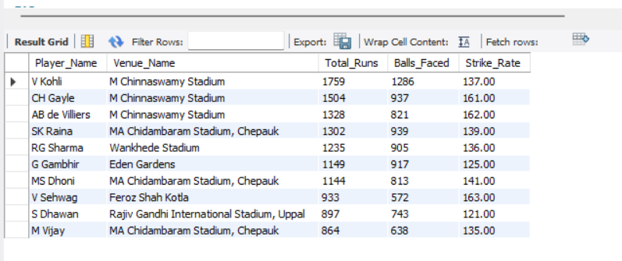

**Visualization:**

**Conclusion:** These two queries provide valuable insights into the performance of bowlers and batsmen in a cricket tournament. By analysing death over bowling performance and batting performance across different venues, coaches and selectors can:

Identify bowlers who are most effective in death overs and can be relied upon to restrict the opposition's score.

Identify batsmen who perform well at specific venues and can be selected accordingly.

Develop strategies to counter the strengths and weaknesses of opposing teams.

Make informed decisions about team selection and player development.

By combining these insights with other performance metrics, coaches and selectors can build a well-rounded team with a strong balance of batting, bowling, and all-rounding abilities.

Suggestions

|  |  |
| --- | --- |
| Captain | Shreyas iyer |
| batting | Shreyas iyer |
|  | KOHLI |
| Bowlers: | jasprit bumrah |
|  | yuzvendra chahal |
| coach | Mahela jayawardhane |

1. What are some of parameters that should be focused while selecting the players?  
   **Approach:** To analyse the performance of batsmen and bowlers, the query takes the following approach: joins tables, filter matches, group by player, calculation metric, sort and limit.

**SQL query:**

#Key parameters for selecting players

# A. Death over bowling performance

SELECT p.Player_Name,

SUM(CASE WHEN bb.Over_Id >= 16 AND bb.Over_Id <= 20 AND p.Player_Id IN (SELECT Bowler FROM ball_by_ball) THEN b.Runs_Scored ELSE 0 END) AS Death_Over_Runs_Conceded

FROM player p

JOIN ball_by_ball bb ON p.Player_Id = bb.Striker OR p.Player_Id = bb.Bowler

JOIN batsman_scored b ON bb.Match_Id = b.Match_Id AND bb.Over_Id = b.Over_Id AND bb.Ball_Id = b.Ball_Id AND bb.Innings_No = b.Innings_No

GROUP BY p.Player_Name

HAVING COUNT(bb.Ball_Id) > 100 AND Death_Over_Runs_Conceded != 0

ORDER BY Death_Over_Runs_Conceded ASC

LIMIT 10;

# B. Batting performance accross different venues

SELECT p.Player_Name,

v.Venue_Id,v.Venue_Name,

SUM(b.Runs_Scored) AS Total_Runs,

COUNT(b.Ball_Id) AS Balls_Faced,

ROUND(SUM(b.Runs_Scored) / COUNT(b.Ball_Id), 2)*100 ASStrike_Rate

FROM player p

JOIN ball_by_ball bb ON p.Player_Id = bb.Striker

JOIN matches m ON bb.Match_Id = m.Match_Id

JOIN venue v ON m.Venue_Id = v.Venue_Id

JOIN batsman_scored b

ON b.Match_Id = bb.Match_Id AND b.Over_Id = bb.Over_Id ANDb.Ball_Id = bb.Ball_Id AND b.Innings_No = bb.Innings_No

GROUP BY p.Player_Name, v.Venue_Name

ORDER BY Total_Runs DESC, Strike_Rate DESC LIMIT 10;

**Output:**

For bowlers:

For batsman:



**Visualization:**

**Conclusion:** These two queries provide valuable insights into the performance of bowlers and batsmen in a cricket tournament. By analysing death over bowling performance and batting performance across different venues, coaches and selectors can:

Identify bowlers who are most effective in death overs and can be relied upon to restrict the opposition's score.

Identify batsmen who perform well at specific venues and can be selected accordingly.

Develop strategies to counter the strengths and weaknesses of opposing teams.

Make informed decisions about team selection and player development.

By combining these insights with other performance metrics, coaches and selectors can build a well-rounded team with a strong balance of batting, bowling, and all-rounding abilities.

1. Which players offer versatility in their skills and can contribute effectively with both bat and ball? (can you visualize the data for the same)  
   **Approach:** first finding batting performance for players, then bowling performance for players and joining them on player id to get common players who offers versitality

**SQL query:**

WITH batting_performance AS (

SELECT p.Player_Id, p.Player_Name,

SUM(b.Runs_Scored) AS Total_Runs,

COUNT(bb.Ball_Id) AS Balls_Faced,

ROUND((SUM(b.Runs_Scored) / COUNT(bb.Ball_Id))*100,2) AS Batting_Strike_Rate

FROM player p

JOIN ball_by_ball bb ON p.Player_Id = bb.Striker

JOIN batsman_scored b ON bb.Match_Id = b.Match_Id

AND bb.Over_Id = b.Over_Id

AND bb.Ball_Id = b.Ball_Id

AND bb.Innings_No = b.Innings_No

GROUP BY p.Player_Id, p.Player_Name

),

bowling_performance AS (

SELECT p.Player_Id, p.Player_Name,

COUNT(w.Player_Out) AS Total_Wickets,

ROUND(SUM(bb.Team_Batting) / COUNT(bb.Ball_Id),2) AS Economy_Rate

FROM player p

JOIN ball_by_ball bb ON p.Player_Id = bb.Bowler

JOIN wicket_taken w ON bb.Match_Id = w.Match_Id

AND bb.Over_Id = w.Over_Id

AND bb.Ball_Id = w.Ball_Id

AND bb.Innings_No = w.Innings_No

GROUP BY p.Player_Id, p.Player_Name

)

SELECT bp.Player_Id, bp.Player_Name,

bp.Total_Runs, bp.Batting_Strike_Rate, bp.Balls_Faced,

bw.Total_Wickets, bw.Economy_Rate

FROM batting_performance bp

JOIN bowling_performance bw ON bp.Player_Id = bw.Player_Id

ORDER BY bp.Batting_Strike_Rate DESC, bw.Economy_Rate ASC

LIMIT 10;

**Output:**

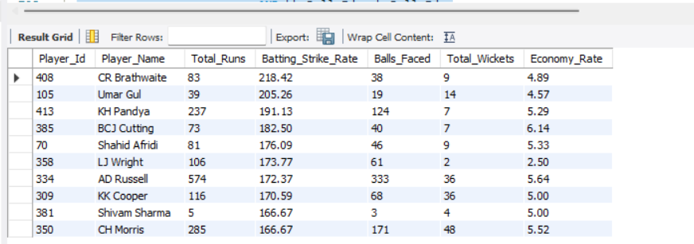

**Visualization:**

**Conclusion:** This query analyses the performance of cricket players, combining their batting and bowling statistics. It calculates:

Batting performance: total runs, balls faced, and batting strike rate

Bowling performance: total wickets taken and economy rate

The results are sorted by batting strike rate in descending order and economy rate in ascending order, highlighting the top all-round performers. The query provides a comprehensive view of each player's strengths and weaknesses, enabling coaches and selectors to make informed decisions about team selection and strategy development.

1. Are there players whose presence positively influences the morale and performance of the team? (justify your answer using visualisation)  
     
   **Approach:** To find players presence positively influences the morale and performance of the team by calculating wins with player, matches with player, win rate with player, win without player, total matches, win rate without player.

**SQL query:**

WITH player_influence AS (

-- Check team's win rate when player is in the playing 11

SELECT pm.Player_Id, p.Player_Name,

SUM(CASE WHEN m.Match_Winner = pm.Team_Id THEN 1 ELSE 0 END) AS Wins_With_Player,

COUNT(pm.Match_Id) AS Matches_With_Player

FROM player_match pm

JOIN matches m ON pm.Match_Id = m.Match_Id

JOIN player p ON pm.Player_Id = p.Player_Id

WHERE pm.Team_Id = 2

GROUP BY pm.Player_Id, p.Player_Name

),

team_win_rate AS (

-- Calculate overall team win rate

SELECT m.Team_1 AS Team_Id,

SUM(CASE WHEN m.Match_Winner = 2 THEN 1 ELSE 0 END) AS Wins_Without_Player,

COUNT(m.Match_Id) AS Total_Matches

FROM matches m

WHERE (m.Team_1 = 2 OR m.Team_2 = 2) -- RCB

GROUP BY m.Team_1

)

SELECT pi.Player_Name, pi.Wins_With_Player, pi.Matches_With_Player,

ROUND((pi.Wins_With_Player / pi.Matches_With_Player) * 100, 2) AS Win_Rate_With_Player,

tw.Wins_Without_Player, tw.Total_Matches,

ROUND((tw.Wins_Without_Player / tw.Total_Matches) * 100, 2) ASWin_Rate_Without_Player

FROM player_influence pi

JOIN team_win_rate tw ON pi.Player_Id = tw.Team_Id

ORDER BY Win_Rate_With_Player DESC;

**Output:**

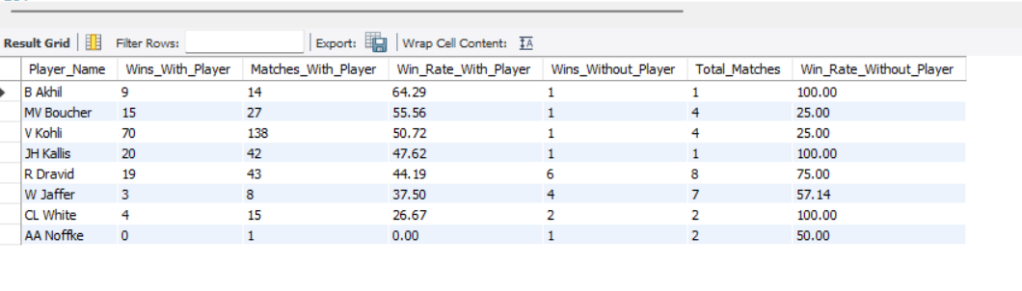**Visualization:**

**Conclusion:** Sometime, a team’s performance is affected by a player’s presence on the field.

In our data, we can observe that in Virat Kohli’s presence, RCB has won almost 51% of their matches, which indicates how strongly him being on the field affects the team’s moral and performance

We can also see that the team has won only 25% percent of the matches without Kohli’s presence.

Making sure that players who have such positive impact on field arealways given a chance is key to the team’s success and player’s moral.

1. What would you suggest to RCB before going to mega auction ?

* Rcb management lacks positivity.
* Players are giving everything for the team-ownership lacks positivity.
* Think tank should be changed and key batters like virat ,will jacks and maxwell must be retained.
* Bowling should be strengthened

Batting Performance:

* KH Pandya has the highest batting strike rate, followed closely by AD Russell.
* S Jayasuriya has the lowest batting strike rate among the players shown.
* Most players have batting strike rates between 150 and 200, indicating aggressive batting styles typical in T20 cricket.

Bowling Economy:

* GJ Maxwell has the highest economy rate, suggesting he's the most expensive bowler in terms of runs conceded per over.
* S Jayasuriya has the lowest economy rate, making him the most economical bowler of the group.
* There's significant variation in economy rates, ranging from about 6 to 10 runs per over.

All-round Performance:

* Some players like KH Pandya and AD Russell show high batting strike rates but also higher economy rates, suggesting they're aggressive all-rounders.
* Players like S Jayasuriya and MF Maharoof have lower batting strike rates but also lower economy rates, indicating they might be more defensive or specialist bowlers.

The data suggests different player roles - some are clearly batting specialists with high strike rates, others are bowling specialists with low economy rates, and some are all-rounders balancing both aspects.

1. What do you think could be the factors contributing to the high-scoring matches and the impact on viewership and team strategies

* Chinnaswamy stadium is one of the smallest stadiums in india.
* So it always brings fun to the match...batters usually smash the bowlers all around the ground and some rival games agaisnt csk and mi were so iconic in this stadium...
* Although it is small, rcb management always fails to find right talent to play at chinnaswamy stadium. this is a major drawback and a substantial reason for their trophy drought.
* calculating the factors which are contributing to the high – scoring matches and the impact on viewership and team strategies using two factors 1) power play and death over scores ,2)average runs on each venue.

**SQL query:**

SELECT t.Team_Name,

SUM(CASE WHEN bb.Over_Id BETWEEN 1 AND 6 THEN b.Runs_Scored ELSE 0 END) AS Powerplay_Runs,

SUM(CASE WHEN bb.Over_Id BETWEEN 16 AND 20 THEN b.Runs_Scored ELSE 0 END) AS Death_Over_Runs

FROM team t

JOIN matches m ON t.Team_Id = m.Team_1 OR t.Team_Id = m.Team_2

JOIN ball_by_ball bb ON m.Match_Id = bb.Match_Id

JOIN batsman_scored b ON bb.Match_Id = b.Match_Id AND bb.Over_Id = b.Over_Id AND bb.Ball_Id = b.Ball_Id

GROUP BY t.Team_Name

ORDER BY Powerplay_Runs DESC, Death_Over_Runs DESC;

/* High Scoring Venues: Some venues favour the batsmen more then others, venues play a significant role in a high-scoring match */

SELECT v.Venue_Name,

AVG(match_runs.Total_Runs) AS Avg_Runs_Per_Match,

COUNT(m.Match_Id) AS Total_Matches

FROM venue v

JOIN matches m ON v.Venue_Id = m.Venue_Id

JOIN (

SELECT bb.Match_Id, SUM(b.Runs_Scored) AS Total_Runs

FROM ball_by_ball bb

JOIN batsman_scored b ON bb.Match_Id = b.Match_Id

AND bb.Over_Id = b.Over_Id

AND bb.Ball_Id = b.Ball_Id

GROUP BY bb.Match_Id

) AS match_runs ON m.Match_Id = match_runs.Match_Id

GROUP BY v.Venue_Name

ORDER BY Total_Matches DESC,Avg_Runs_Per_Match DESC

LIMIT 10;

**Output:**

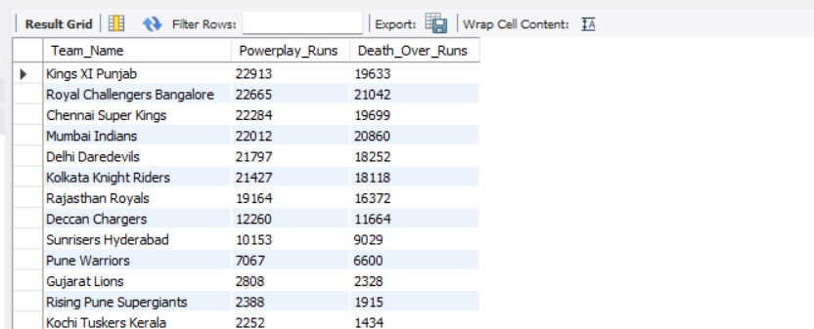

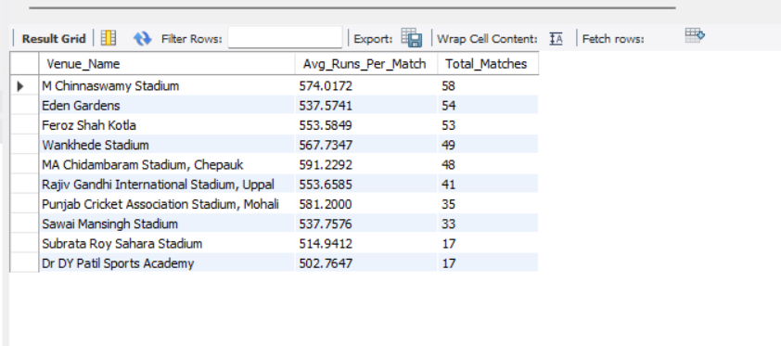

**Visualization:**

**Conclusion:** 1) This graph compares the performance of different cricket teams in power play and death overs. Kings XI Punjab leads in both categories, scoring the most runs in power play (22,913) and death overs (15,833). There's a clear trend showing that teams with higher power play scores generally also have higher death over scores, indicating consistent aggressive batting throughout the innings. However, the gap between power play and death over runs narrows for teams lower on the list, suggesting these teams might struggle more in the final overs compared to their early innings performance.

* 2) The graph illustrates the average runs scored per match at different cricket venues, alongside the total number of matches played at each. M Chinnaswamy Stadium in Bangalore stands out as the highest-scoring venue with an average of 574 runs per match, while also hosting a significant number of games (58). There's a general trend showing that venues with more matches played tend to have higher average run scores, suggesting that familiarity with the ground or its batting-friendly nature may contribute to higher scoring games.

1. Analyze the impact of home ground advantage on team performance and identify strategies to maximize this advantage for RCB.  
   **Approach:** for resolving this issue, we can calculate home vs away performances like wins, losses, total matches, win_percentage, batting performance, bowling performance

**SQL query:**

# Home vs Away Win/Loss record

WITH win_loss_record AS (

SELECT m.Match_Id, v.Venue_Name,

CASE WHEN m.Match_Winner = 2 THEN 'Win' ELSE 'Loss'

END AS Result,

CASE WHEN v.Venue_Id = 1 THEN 'Home' ELSE 'Away'

END AS Venue_Type

FROM matches m

JOIN venue v ON m.Venue_Id = v.Venue_Id

WHERE (m.Team_1 = 2 OR m.Team_2 = 2) AND Outcome_type != 2

)

SELECT

Venue_Type,

COUNT(CASE WHEN Result = 'Win' THEN 1 END) AS Wins,

COUNT(CASE WHEN Result = 'Loss' THEN 1 END) AS Losses,

COUNT(*) AS Total_Matches,

ROUND(COUNT(CASE WHEN Result = 'Win' THEN 1 END) / COUNT(*) * 100, 2) AS Win_Percentage

FROM win_loss_record

GROUP BY Venue_Type;

#Home away batting performance

WITH rcb_run_stats AS (

SELECT m.Match_Id, v.Venue_Name,

CASE WHEN v.Venue_Id = 1 THEN 'Home' ELSE 'Away'

END AS Venue_Type,

SUM(CASE WHEN bb.Team_Batting = 2 THEN b.Runs_Scored ELSE 0 END) AS Runs_Scored,

SUM(CASE WHEN bb.Team_Bowling = 2 THEN b.Runs_Scored ELSE 0 END) AS Runs_Conceded

FROM matches m

JOIN venue v ON m.Venue_Id = v.Venue_Id

JOIN ball_by_ball bb ON m.Match_Id = bb.Match_Id

JOIN batsman_scored b ON bb.Match_Id = b.Match_Id

AND bb.Over_Id = b.Over_Id

AND bb.Ball_Id = b.Ball_Id

WHERE (m.Team_1 = 2 OR m.Team_2 = 2) -- 2 is the team ID for RCB

GROUP BY m.Match_Id, v.Venue_Name

)

SELECT Venue_Type,

ROUND(AVG(Runs_Scored),2) AS Avg_Runs_Scored,

ROUND(SUM(Runs_Scored),2) AS Total_runs_scored

FROM rcb_run_stats

GROUP BY Venue_Type;

#Bowling performance at home

WITH bowling_performance AS (

SELECT v.Venue_Name,

CASE WHEN v.Venue_Id = 1 THEN 'Home' ELSE 'Away'

END AS Venue_Type,

SUM(CASE WHEN bb.Team_Bowling = 2 THEN b.Runs_Scored ELSE 0 END) AS Runs_Conceded,

COUNT(CASE WHEN bb.Team_Bowling = 2 THEN w.Player_Out ELSE NULL END) AS Wickets_Taken,

COUNT(CASE WHEN bb.Team_Bowling = 2 THEN bb.Ball_Id ELSENULL END) AS Balls_Bowled

FROM matches m

JOIN venue v ON m.Venue_Id = v.Venue_Id

JOIN ball_by_ball bb ON m.Match_Id = bb.Match_Id

JOIN wicket_taken w ON bb.Match_Id = w.Match_Id

AND bb.Over_Id = w.Over_Id

AND bb.Ball_Id = w.Ball_Id

JOIN batsman_scored b ON bb.Match_Id = b.Match_Id

AND bb.Over_Id = b.Over_Id

AND bb.Ball_Id = b.Ball_Id

WHERE (m.Team_1 = 2 OR m.Team_2 = 2) -- 2 is the team ID for RCB

GROUP BY v.Venue_Name

)

SELECT Venue_Type,

ROUND(SUM(Wickets_taken),2) AS Total_Wickets_taken,

ROUND(SUM(Runs_Conceded) / SUM(Balls_Bowled), 2) AS Economy_Rate

FROM bowling_performance

GROUP BY Venue_Type;

**OutPut:** 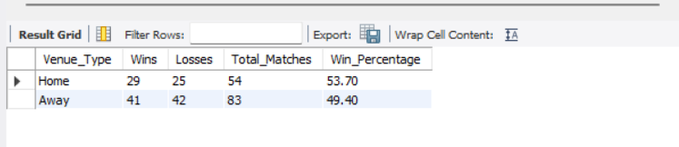

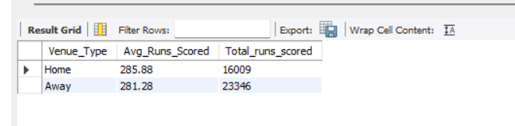

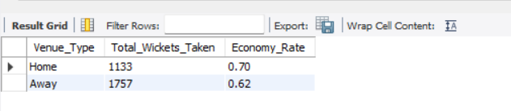

**Visualization:**

**Conclusion:** from above 3 graph we can conclude that when RCB is playing on home ground then performance is good as compared to away. Win percentage is more when RCB is playing at home ground. For batting performance, its good when RCB is playing away and for bowling performance like economy rate is better when they played at home ground as compared to total_wickets_taken.

1. Come up with a visual and analytical analysis with the RCB past seasons performance and potential reasons for them not winning a trophy.  
     
   **Approach:** For resolving this issue first we find win percentage over the seasons and then calculate batting performance over the seasons like total runs in power play, strike rate in power play etc. and bowling perforce like runs conceded in death, total balls in death, economy rate, total wickets in death etc.

**SQL query:**

# A. Win-Loss Performance Over Seasons

WITH win_loss_record AS (

SELECT m.Season_Id,CASE WHEN m.Match_Winner = 2 THEN 'Win' ELSE 'Loss' END AS Result

FROM matches m

WHERE (m.Team_1 = 2 OR m.Team_2 = 2) AND Outcome_type != 2

)

SELECT Season_Id,COUNT(CASE WHEN Result = 'Win' THEN 1 END) AS Wins,

COUNT(CASE WHEN Result = 'Loss' THEN 1 END) AS Losses,

COUNT(*) AS Total_Matches,

ROUND(COUNT(CASE WHEN Result = 'Win' THEN 1 END) / COUNT(*) * 100, 2) AS Win_Percentage

FROM win_loss_record

GROUP BY Season_Id

ORDER BY Season_Id;

# B. Batting performance each season

WITH rcb_batting_in_death_overs AS (

SELECT bs.Match_Id, bs.Innings_No, bb.Striker AS Batsman_Id, p.Player_Name,

SUM(bs.Runs_Scored) AS total_runs_in_power_play,

COUNT(bb.Ball_Id) AS balls_faced_in_power_play

FROM Batsman_Scored bs

JOIN Ball_by_Ball bb ON bs.Match_Id = bb.Match_Id

AND bs.Over_Id = bb.Over_Id

AND bs.Ball_Id = bb.Ball_Id

AND bs.Innings_No = bb.Innings_No

JOIN Matches m ON bs.Match_Id = m.Match_Id

JOIN Player p ON bb.Striker = p.Player_Id

WHERE (m.Team_1 = 2 OR m.Team_2 = 2)

AND bs.Over_Id BETWEEN 1 AND 6

GROUP BY bs.Match_Id, bs.Innings_No, bb.Striker, p.Player_Name

)

SELECT p.Player_Name,

SUM(rcb.total_runs_in_power_play) AS total_runs_in_power_play,

SUM(rcb.balls_faced_in_power_play) AS total_balls_faced_in_death_overs,

ROUND((SUM(rcb.total_runs_in_power_play) / SUM(rcb.balls_faced_in_power_play)) * 100, 2) AS strike_rate_in_power_play

FROM rcb_batting_in_death_overs rcb

JOIN Player p ON rcb.Batsman_Id = p.Player_Id

GROUP BY p.Player_Name

HAVING total_balls_faced_in_death_overs >100

ORDER BY strike_rate_in_power_play DESC;

# C. Bowling performance each season

WITH death_overs_bowling AS (

SELECT bb.Match_Id, bb.Innings_No, bb.Bowler, p.Player_Name,

SUM(bs.Runs_Scored) AS runs_conceded,

COUNT(bb.Ball_Id) AS balls_bowled,

COUNT(w.Player_Out) AS wickets_taken

FROM ball_by_ball bb

JOIN batsman_scored bs ON bb.Match_Id = bs.Match_Id

AND bb.Over_Id = bs.Over_Id

AND bb.Ball_Id = bs.Ball_Id

AND bb.Innings_No = bs.Innings_No

LEFT JOIN wicket_taken w ON bb.Match_Id = w.Match_Id

AND bb.Over_Id = w.Over_Id

AND bb.Ball_Id = w.Ball_Id

AND bb.Innings_No = w.Innings_No

JOIN player p ON bb.Bowler = p.Player_Id

JOIN matches m ON bb.Match_Id = m.Match_Id

WHERE (m.Team_1 = 2 OR m.Team_2 = 2)

AND bb.Over_Id BETWEEN 16 AND 20

GROUP BY bb.Match_Id, bb.Innings_No, bb.Bowler, p.Player_Name

)

SELECT p.Player_Name,

SUM(d.runs_conceded) AS runs_conceded_in_death,

SUM(d.balls_bowled) AS total_balls_bowled_in_death,

SUM(d.wickets_taken) AS total_wickets_in_death,

ROUND((SUM(d.runs_conceded) / (SUM(d.balls_bowled) / 6)), 2) AS economy_rate_in_death

FROM death_overs_bowling d

JOIN player p ON d.Bowler = p.Player_Id

JOIN matches m ON d.Match_Id = m.Match_Id

WHERE (m.Team_1 = 2 OR m.Team_2 = 2)

GROUP BY p.Player_Name

HAVING total_balls_bowled_in_death > 100

ORDER BY economy_rate_in_death DESC;

**Output:**

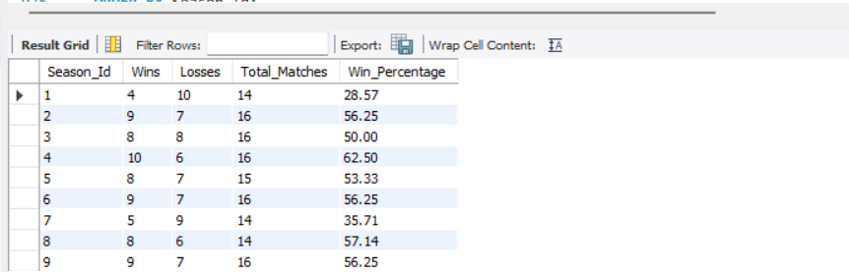

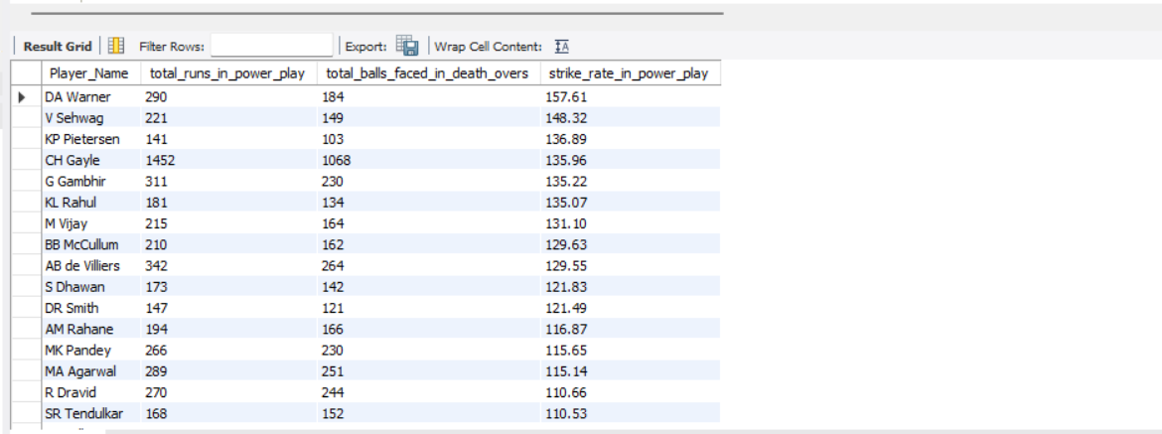

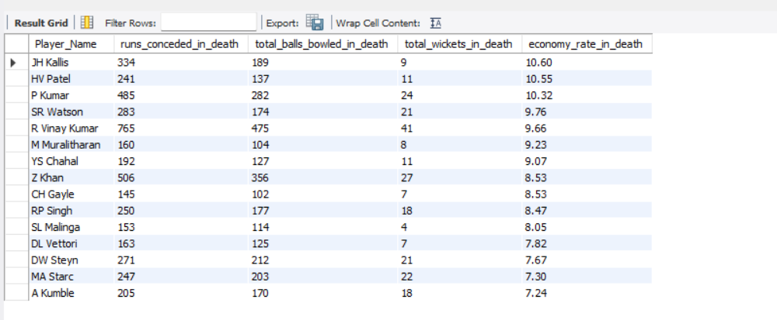

**Visualization:**

**Conclusion:** From the first graph,it shows the win percentage over 9 seasons. There's a general upward trend in win percentage, starting at 28.57% in season 1 and ending at 56.25% in season 9. The win percentage fluctuates between seasons, with notable peaks in seasons 3 and 5, reaching 62.5% at its highest point.

From second graph, it shows batting performance across multiple seasons, tracking total runs in power play, total balls faced in death overs, and strike rate in power play. There's significant variation between players, with a few standout performances in runs and balls faced. The strike rate generally follows a declining trend across the seasons, with some fluctuations.

From third graph, it depicts bowling performance across seasons for different players, showing runs conceded, balls bowled, wickets taken, and economy rate in death overs. There's significant variation among players, with some standout performances in wickets taken (e.g., P Kumar, Y Chahal). Economy rates remain relatively consistent across players, while runs conceded and balls bowled vary more widely.

To overcome their trophy drought, RCB needs to address the following:

* **Management Stability**: Building a consistent management and leadership structure is crucial for long-term success.
* **Player Backing**: Creating a culture where players are backed despite a few failures would improve morale and team cohesion.
* **Mental Strength**: Instilling a winning mentality by embracing pressure and focusing on performing in key moments could help the team break their final hurdles.
* **Balanced Team**: Relying on a few stars has not worked for them. RCB needs to focus on building a well-rounded team where both batting and bowling departments are strong.

1. How would you approach this problem, if the objective and subjective questions weren't given?

**1. Define Objectives**

Primary Goal

Identify top-performing and reliable players who offer the best value for money.

**Secondary Goals:**

Ensure a balanced team composition, consider future potential

**2. Data Collection**

Player Performance Data: Gather historical performance data for players, including batting averages, strike rates, bowling economy, and fielding statistics.

Player Profiles: Consider age, fitness levels, and versatility.

**3. Data Analysis**

Performance Metrics: Calculate key performance indicators (KPIs) such as runs scored, wickets taken, and catches/stumpings.

Consistency: Evaluate consistency by looking at performance over multiple seasons.

**4. Player Segmentation**

Core Players

Identify players who consistently perform well and can form the backbone of the team.

1. In the "Match" table, some entries in the "Opponent_Team" column are incorrectly spelled as "Delhi_Capitals" instead of "Delhi_Daredevils". Write an SQL query to replace all occurrences of "Delhi_Capitals" with "Delhi_Daredevils"

SQL Query

UPDATE Team

SET Team_Name = 'Delhi_Capitals'

WHERE Team_Name = Delhi_Daredevils '  
And Team_Id=6.

Output

